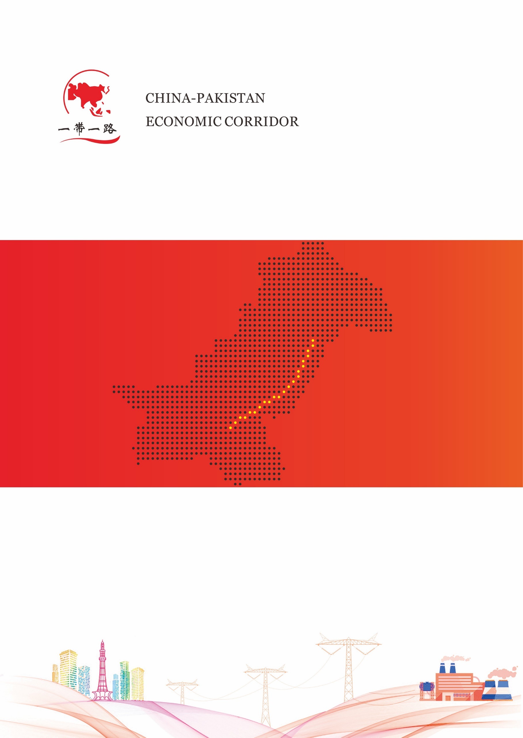

默拉直流管理处

2021年 月

**拉合尔换流站**

**阀厅熄灯巡视记录表**

阀厅熄灯巡视记录

Valve Hall Lights Out Patrol Record

日期（Date）： 年y 月m 日d 直流功率（MW）： ℃ 运检（Team）： 值

|  |  |  |  |  |  |
| --- | --- | --- | --- | --- | --- |
| **序号**  **Order** | **巡视项目**  **Content** | **设备名称**  **Equipment** | | **执行情况**  **Execution** | **备注**  **note** |
| 1 | 1.1引线及连接线夹无放电、发红  1.2穿墙套管无放电及异常响声  1.1 the lead wire and connecting clamp have no discharge and redness  1.2 there is no discharge and abnormal noise in the wall bushing | 穿墙套管  Bushing | 极Ⅰ阀厅极线U1P穿墙套管  U1P |  |  |
| 极Ⅰ阀厅中性线U1N穿墙套管U1N |  |  |
| 极Ⅱ阀厅极线U2P穿墙套管  U2P |  |  |
| 极Ⅱ阀厅中性线U2N穿墙套管  U2N |  |  |
| 2 | 2.1检查引线、接头无放电、发红过热迹象  2.2检查悬挂绝缘子无闪络、放电痕迹  2.3检查阀组件、阀电抗器、阀避雷器、光纤等设备无异常放电  2.1 check the lead and connector for signs of discharge,redness and overheating  2.2 check whether the suspension insulator has flashover and discharge trace  2.3 check the valve assembly,valve reactor,valve arrester,optical fiber and other equipment for abnormal discharge | 换流阀  Valve | 极Ⅰ Y/Y 阀塔A相  Pole 1 Y/Y Valve Tower A |  |  |
| 极Ⅰ Y/Y 阀塔B相  Pole 1 Y/Y Valve Tower B |  |  |
| 极Ⅰ Y/Y 阀塔C相  Pole 1 Y/Y Valve Tower C |  |  |
| 极Ⅰ Y/D 阀塔A相  Pole 1 Y/D Valve Tower A |  |  |
| 极Ⅰ Y/D 阀塔B相  Pole 1 Y/D Valve Tower B |  |  |
| 极Ⅰ Y/D 阀塔C相  Pole 1 Y/D Valve Tower C |  |  |
| 极Ⅱ Y/Y 阀塔A相  Pole 2 Y/Y Valve Tower B |  |  |
| 极Ⅱ Y/Y 阀塔B相  Pole 2 Y/Y Valve Tower B |  |  |
| 极Ⅱ Y/Y 阀塔C相  Pole 2 Y/Y Valve Tower C |  |  |
| 极Ⅱ Y/D 阀塔A相  Pole 2 Y/D Valve Tower A |  |  |
| 极Ⅱ Y/D 阀塔B相  Pole 2 Y/D Valve Tower B |  |  |
| 极Ⅱ Y/D 阀塔C相  Pole 2 Y/D Valve Tower C |  |  |

巡检人（Inspector）： 值班负责人（In Charge）：